PROJECT TITLE
Title: | Investigating Root Water Uptake Variations between Younger and Older Riparian Trees
Project Number:
Start Date: | 3/1/2021
End Date: | 2/28/2022
Funding Source: | 104B
Congressional District: | CT-002
Research Category: | Climate and Hydrologic Processes
Focus Category: | HYDROL, WQN, FL
Principal Investigators: | PI Name: James Knighton (corresponding PI)  Title: Assistant Professor  Institution: University of Connecticut Department of Natural Resources and the Environment  Address: 1376 Storrs Rd, Storrs, CT 06269-5408, Room 331A  Email: james.knighton@uconn.edu  Phone: 215-317-0980

Summary
Tree vary in their strategies for water uptake, which can influence soil moisture, groundwater recharge, transpiration, and streamflow. Within-species heterogeneity in water uptake is not well understood for Eastern hemlock, a foundational northeastern US forest tree. We measured soil and xylem water isotopic compositions for 30 riparian hemlock trees to track age-related variations in water use.
Soil and xylem water isotopic compositions revealed ephemeral shifts in subsurface water use partitioning: older and lower elevation hemlock sourced water uptake from the upper 5 cm of soils, whereas younger and higher elevation trees sourced water uptake as deep as 20 cm. Larger diameter hemlock showed significant temporal changes in trunk RWC. In contrast, smaller diameter trees exhibited more temporally stable RWC. Observed species-level heterogeneity in xylem water isotope composition suggests the need for reporting of tree ages and a standardization of field sampling protocols to support our understanding of tree water use strategies. Our results inform the development of plant hydraulic strategies in ecohydrological and terrestrial biosphere-models to understand forest responses to external stressors.
Introduction
Hydrologic extremes (i.e., flooding and drought) are likely to increase in frequency and magnitude across the Northeastern US (NE) over the next century with more extended periods of drought and expansion of areas inundated by streamflow following heavy rainfall. Hydrologic assessments of discharge extremes typically maintain a strong focus on uncertain projections of rainfall extremes under climate change with less emphasis on capturing the complexity of plant dynamics, often neglecting to represent the functional strategies that govern plant root regulation of transpiration.
The northern expansion of the hemlock wooly adelgid (Adelges tsugae) is causing a decline in Eastern hemlock (Tsuga canadensis), a foundational Northeastern US (NE) tree species. Isolated catchments with infested hemlock have shown evidence of increased watershed saturation, reduced transpiration, and more extreme floods during the growing season. Preliminary isotopic evidence of soil moisture and xylem water suggests that hemlock may take up and transpire groundwater during periods of shallow soil water limitation; whereas successional trees, such as American Beech, may not. This variation in strategies to survive periods of drought could explain some of the observed shifts in hydrology following hemlock loss and succession.
Current United States Department of Agriculture (USDA) hemlock preservation guidelines establish a stand prioritization based on the economic, ecological, and aesthetic value of hemlock. Our proposed research will determine if there are within-species variations in hemlock Root Water Uptake (RWU) sources by tree age, and by extension, variations in the hydrologic value of hemlock stands. We will estimate hemlock RWU across a range of riparian hemlock ages. We will measure the stable isotopic composition (δ²H and δ¹⁸O) of groundwater, stream, soil, and hemlock xylem water throughout the 2021 growing season (May – October). Stable isotopic tracer measurements will be used to understand how hemlock trees access and store subsurface water throughout the growing season, and if these strategies vary with tree diameter. We hypothesize that older hemlock (diameter > 30 cm) more frequently take up groundwater than younger hemlock during periods of shallow soil water limitation, and therefore exert a greater stabilizing effect on regional groundwater and streamflow regimes.
In addition to the previously described hemlock stand prioritization, this proposed research aligns with ongoing USDA investigations into the ecological function and value of hemlock at Coweeta Hydrologic Laboratory (North Carolina), and extends this research theme into the NE. The proposed experiments align with ongoing model-based investigations by United States Geological Survey (USGS) scientists at the USGS New England Water Science Center & Silvio O. Conte Anadromous Fish Research Laboratory to study the impact of land cover change across the NE on streamflow regimes, ecoflows, and freshwater fish habitat. Finally, management of the flood risk profile of the NE requires a diversified portfolio of strategies which leverage investments in capital projects (e.g. flood control structures), financial tools to allow residents to mitigate risk (e.g. flood insurance), and investments in forest management to reduce the frequency of extreme runoff events. To this end, our work aligns with ongoing efforts by the Federal Emergency Management Agency (FEMA) to advance equitable flooding solutions across the NE.
Objective(s)
The objectives of this research were to 1) understand age-related variations in water use by eastern hemlock, and 2) age-related variations in trunk water storage.

Results/Discussion
Soil and xylem water isotopic compositions revealed ephemeral shifts in subsurface water use partitioning: older and lower elevation hemlock sourced water uptake from the upper 5 cm of soils, whereas younger and higher elevation trees sourced water uptake as deep as 20 cm (Fig 1). Larger diameter hemlock showed significant temporal changes in trunk RWC. In contrast, smaller diameter trees exhibited more temporally stable RWC (Fig 2). These results are currently under review at Hydrology and Earth Systems Science (Li & Knighton, 2022).
Figure 1 – Dual Isotope plot showing xylem and soil samples.
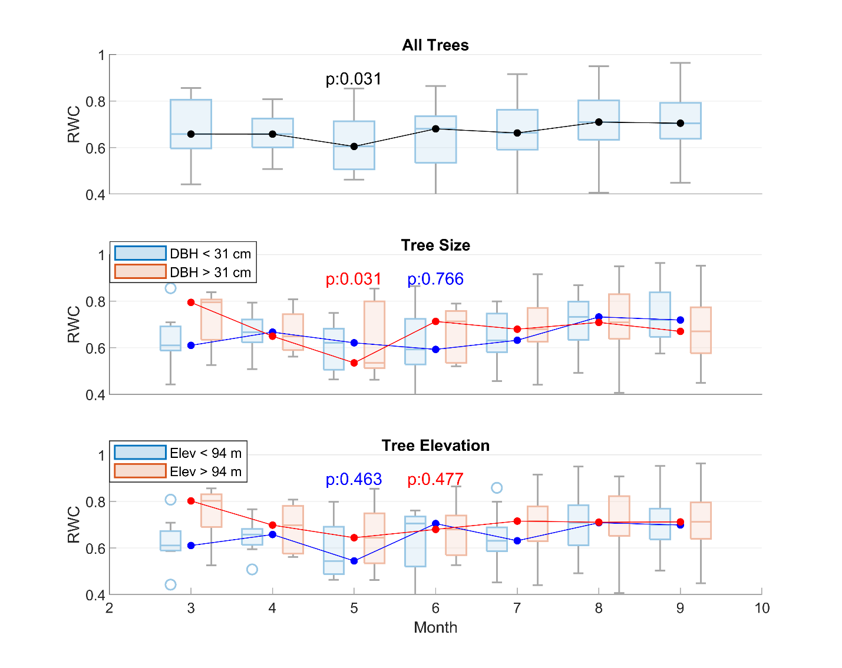
Figure 2 – Tree core relative water content by month
Conclusions
Understanding the species-level heterogeneity in plant water uptake and storage mechanisms is essential to answering fundamental questions surrounding plant water partitioning and will help to elucidate patterns of forest cover change and water availability under future climate conditions. This research demonstrates the need for reporting of species-level characteristics and development of a standardized methodology for field sampling protocols. Ultimately, these advances support our understanding of hydrology and help to refine modern process-based ecohydrological models through improved simulation of plant hydraulics and critical zone water partitioning.

Acknowledgements
None.
References
Li, K., & Knighton, J. (2022). Water Use Strategy of Riparian Conifers Varies with Tree Size and Depends on Coordination of Water Uptake Depth and Internal Tree Water Storage. EGUsphere, 1-25.

